2020-01-18 - Handout – Two Pointers

# Q1. Next Permutation (Medium, Leetcode #31)

Link: <https://leetcode.com/problems/next-permutation/description/>

A permutation of an array of integers is an arrangement of its members into a sequence or linear order. For example, for arr = [1,2,3], the following are all the permutations of arr: [1,2,3], [1,3,2],

[2, 1, 3], [2, 3, 1], [3,1,2], [3,2,1].

**The next permutation of an array of integers** is the next lexicographically greater permutation of its integer. More formally, if all the permutations of the array are sorted in one container according to their lexicographical order, then the next permutation of that array is the permutation that follows it in the sorted container. If such an arrangement is not possible, the array must be rearranged as the lowest possible order (i.e., sorted in ascending order).

For example, the next permutation of **arr = [1,2,3] is [1,3,2].** Similarly, **the next permutation of arr = [2,3,1] is [3,1,2].**

While the next permutation of arr = [3,2,1] is [1,2,3] because [3,2,1] does not have a lexicographical larger rearrangement.

**Given an array of integers, nums, find the next permutation of nums.** The replacement must be in place and use only constant extra memory.

# A screenshot of a facebook app

# Q2. Rotate List (Medium, Leetcode #61)

Link: <https://leetcode.com/problems/rotate-list/description/>

Given the head of a linked list, rotate the list to the right by k places.

| **Example 1:** A diagram of a number system | **Example 2:** |
| --- | --- |

# Q3. Intersection of two linked lists (Easy, Leetcode #160)

Link: <https://leetcode.com/problems/intersection-of-two-linked-lists/description/>

Given the heads of two singly linked-lists headA and headB, return the node at which the two lists intersect. If the two linked lists have no intersection at all, return null.

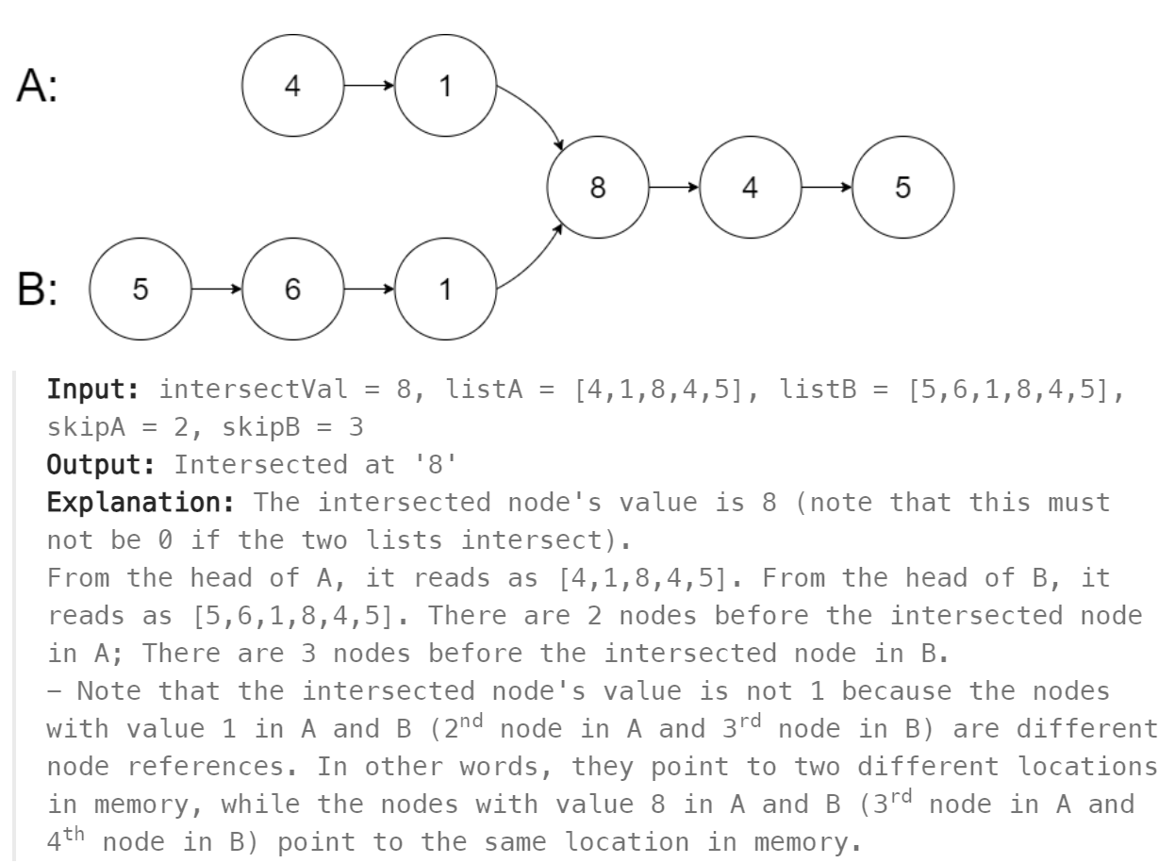

# Q4. Partition List (Medium, Leetcode #86)

Link: <https://leetcode.com/problems/partition-list/description/>

Given the head of a linked list and a value x, partition it such that all nodes less than x come before nodes greater than or equal to x.

You should preserve the original relative order of the nodes in each of the two partitions.

